Friday, 31 July 2026
Dear Parents and Carers

Australia WOW Week

Today has seen the start of yet another new WOW week here at St. Michael’s. As the children arrived, there was didgeridoo music playing, Australian flags flying and some Australian creatures dotted around. Staff were also dressed up in a variety of Australian themed outfits. We are looking forward to enjoying five days of activities related to Australia and each year group has books set in Australia to look at.

Throughout the week, the children will be participating in learning activities linked to the geography and wildlife of Australia, as well as links to music, art, etc. We are planning that some of these activities will take us outside, around our wonderful grounds, to see if we can find any ‘Aussie’ animals.

On Friday, the children are allowed to come in dressed as anything Australian themed or wearing their national flags colours.

Also on Friday, at 3.30, as you pick up your child, we are opening the doors to your child’s classroom until 4pm so that you are able to come in and share the great work that the children will have been doing throughout the week.

Thank you for all of your continued support. We look forward to sharing our week with you.

Kind regards
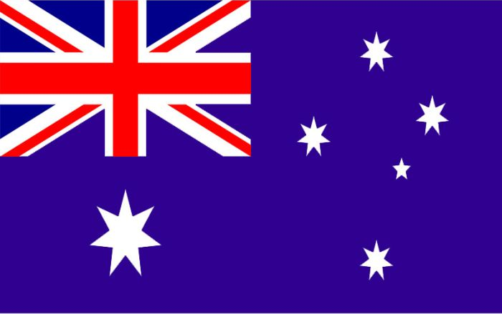
Miss A Whitney
Deputy Headteacher

